Cairo University Faculty of Computers and Artificial Intelligence



**Advanced SE**

**Software design specification document**

**2022**

**Project Team**

|  |  |  |
| --- | --- | --- |
| **ID** | **Name** | **Email** |
| 20200442 | Mohamed Hamdy Mohamed | Mohamedhamdyy55@gmail.com |
| 20201217 | Walaa Hassan Saad | walaa.elbishlawy@gmail.com |
| 20201120 | Aliaa Mohamed Saad | elbashlawyaliaa@gmail.com |
| 20201043 | Basant Mahmoud Mohamed | basant.elshehamy31@gmail.com |

# 

# Class diagram design

# 

# Class diagram Explanation

|  |  |  |
| --- | --- | --- |
| **Design pattern** | **Class follow Design pattern** | **Reason** |
| **Strategy** | 1. WalletPayment 2. Credit Card | In payment we have deferent behavior like wallet and credit Card. |
| **Singleton** | 1. Admin | We make constructor private and get object by get instance we check on information that admin enters from get Instance one object can create |
| **Observer** | 1. Subject (admin)  2. Observer (User) | Observer pattern is used when there is one-to-many relationship between objects such as if one object is modified, its dependents objects are to be notified  Like refund user must notify from admin if admin accept the request. |
| **Adapter** | 1. Ipayment  2. payment | In Ipayment function pay take parameter (amount, User) we make function(pay) in class payment to take just amount make as adapter. |

# Sequence diagram design

**1-Sign Up**

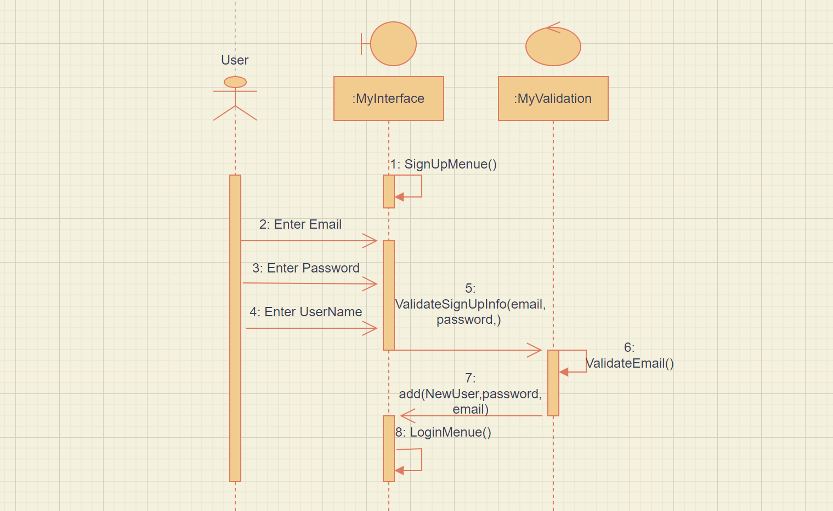

**2-Ask to Refund**

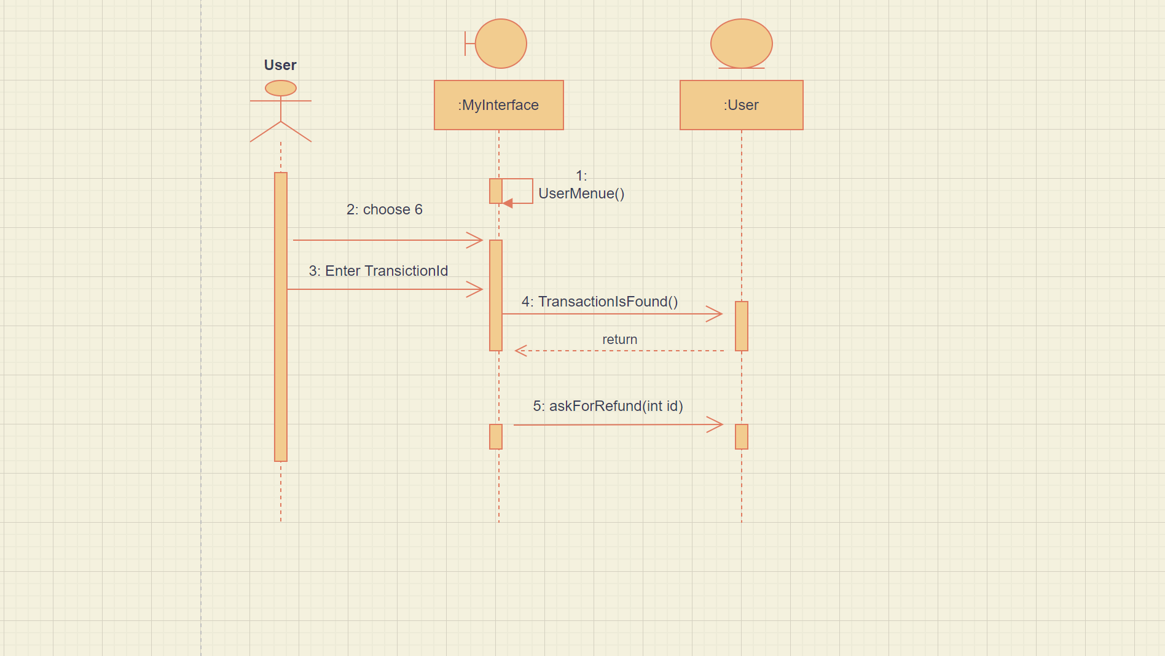

**3-Show List All Refunds**

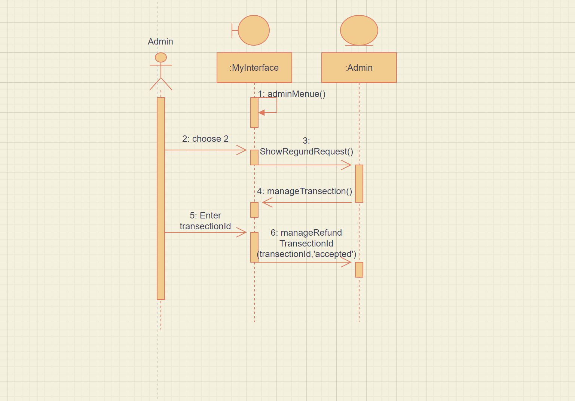

**4-Mobile Recharge**

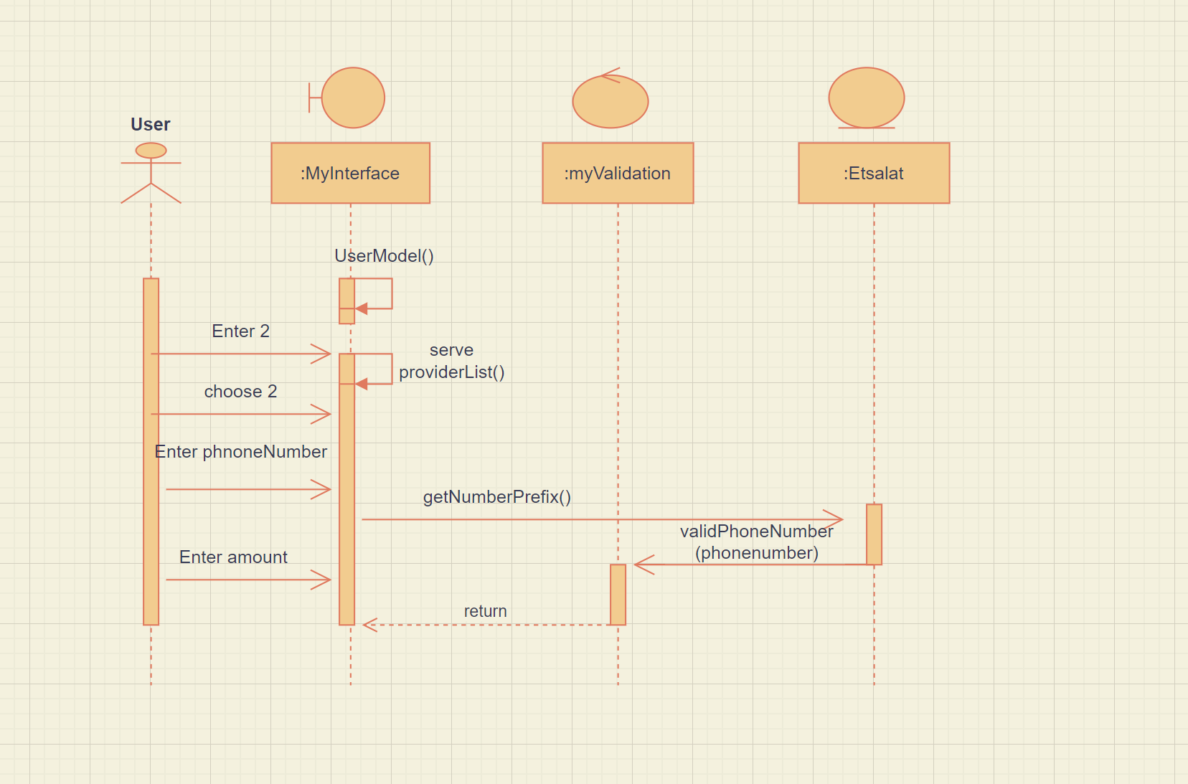

**5-Payment**

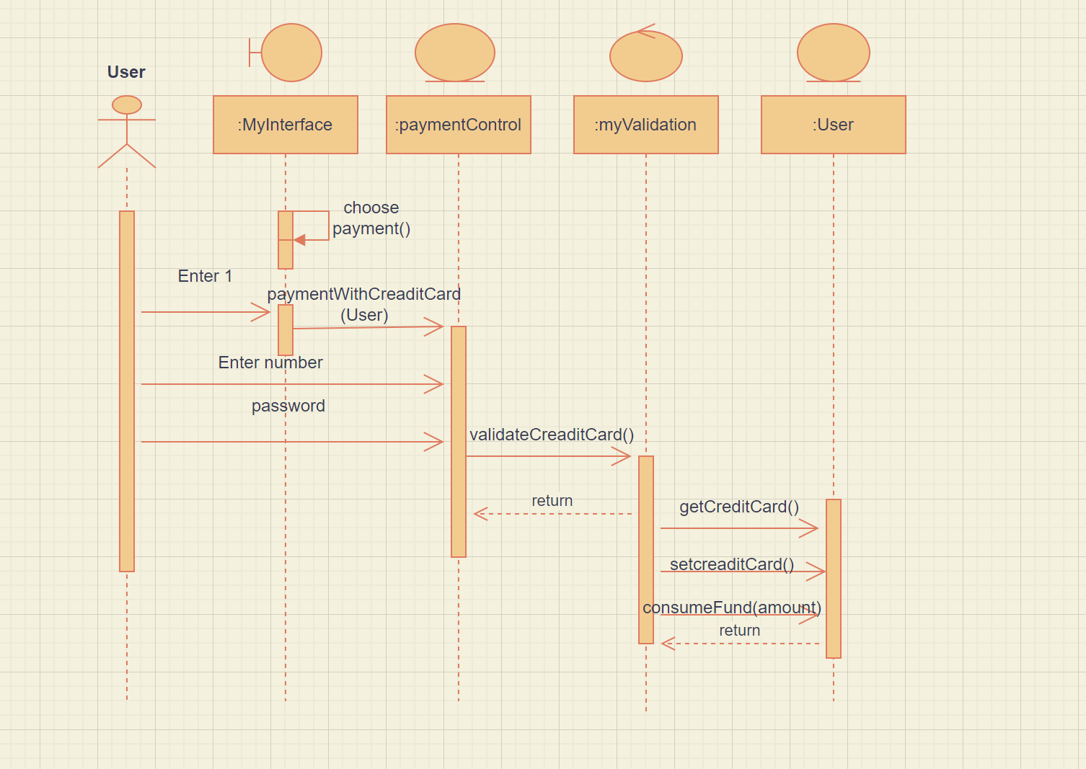

**6-Landline Recharge**

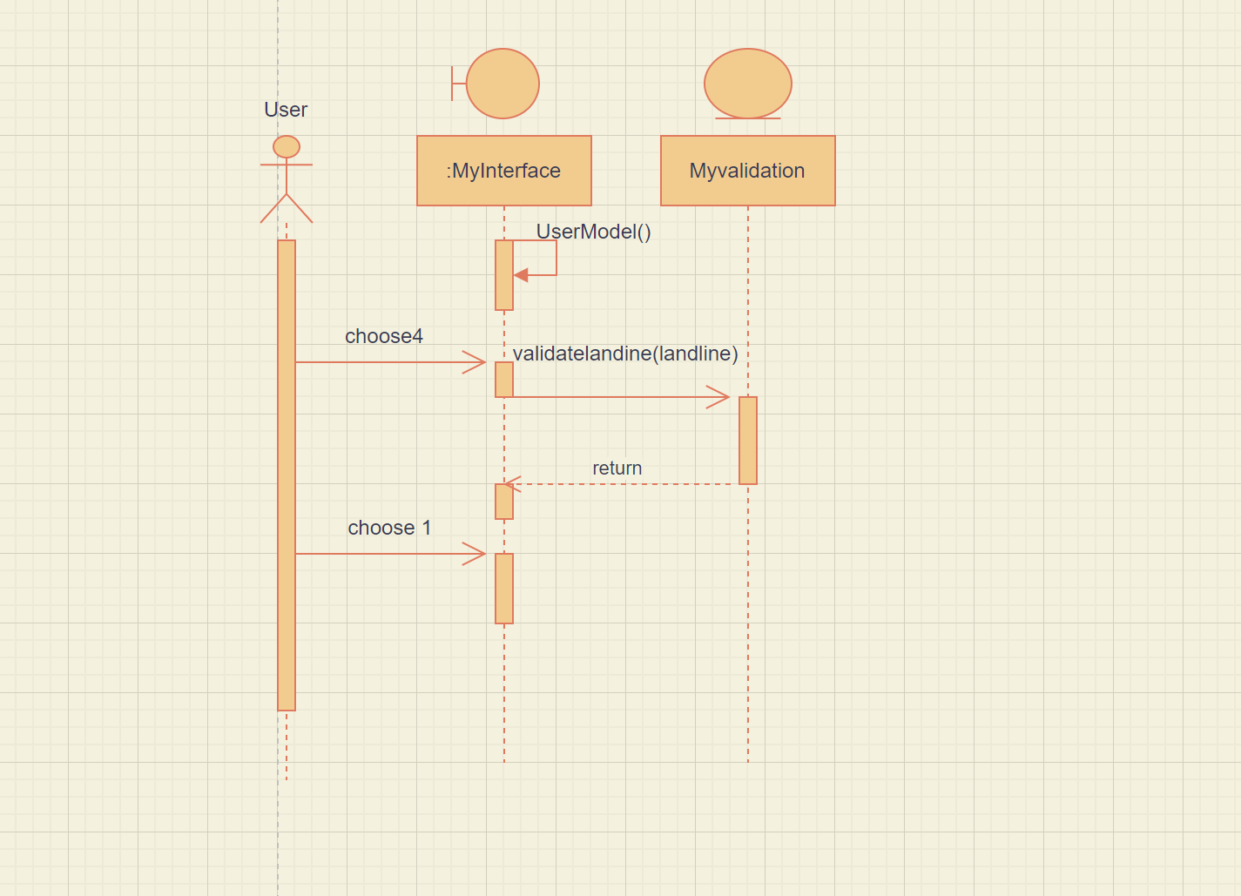

**7-Donations**

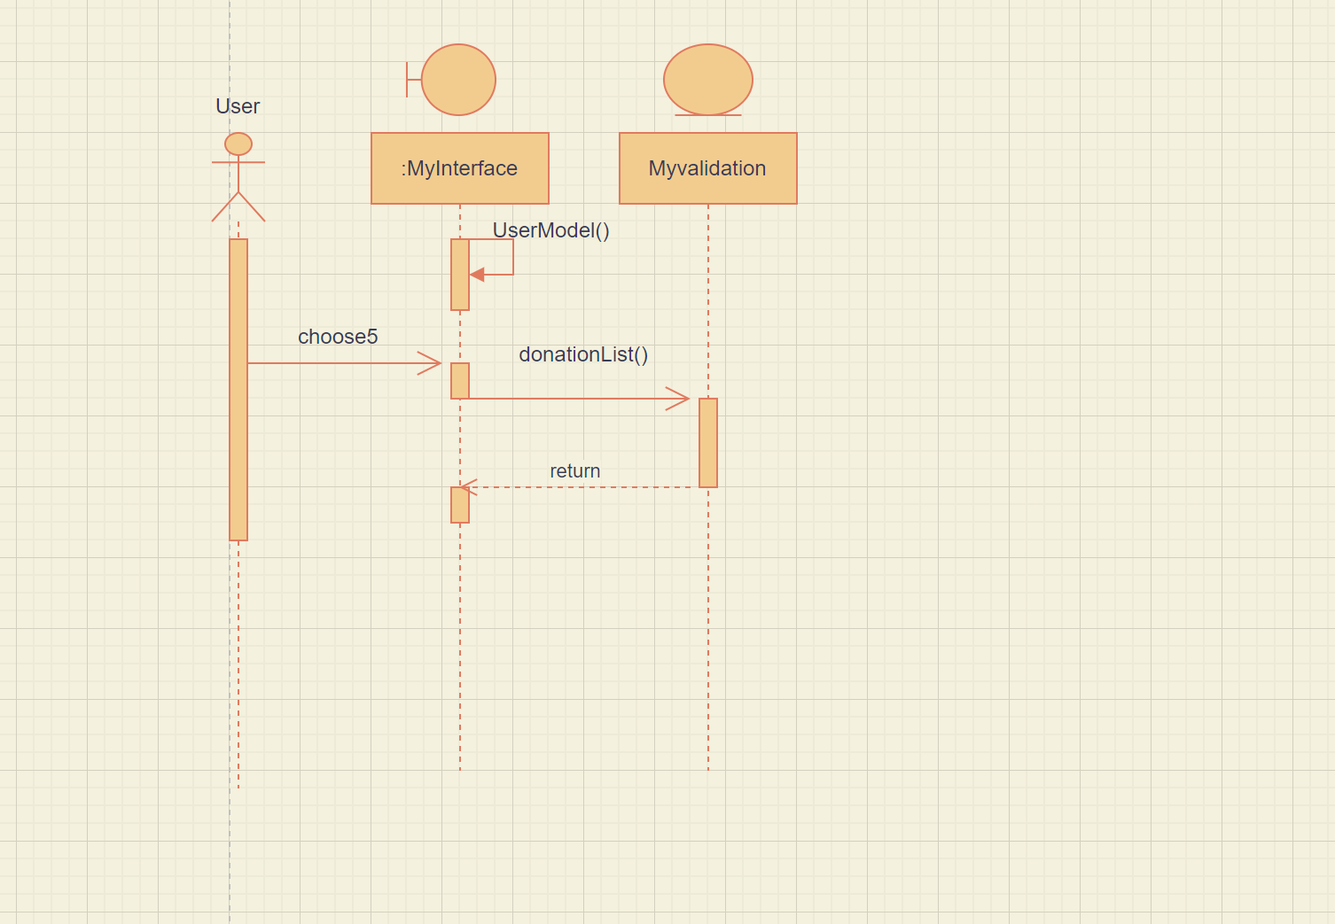

**8-Discount**

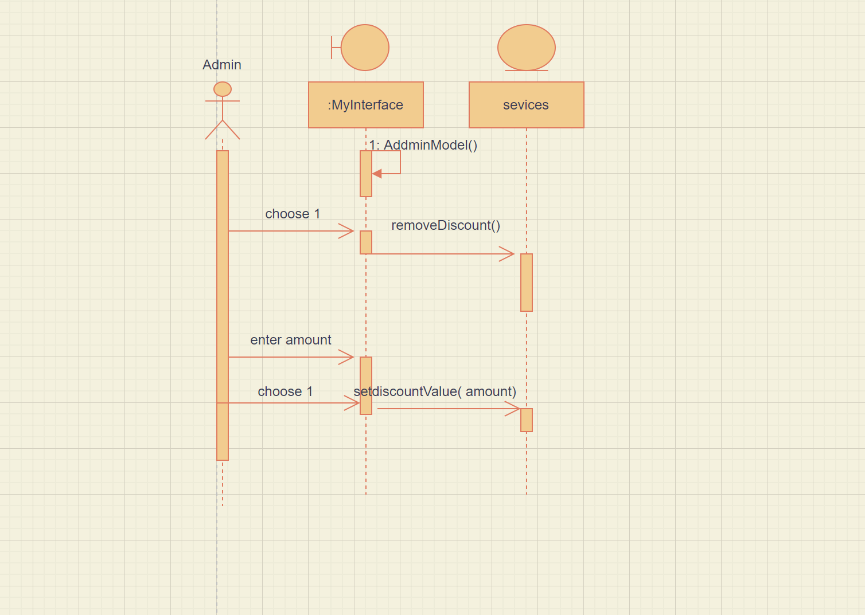

# 

# GitHub repository link